Dr Laura Charlton, Clinical Lead
Gender Identity Service
Leeds and York Partnership NHS Foundation Trust
gid.lypft@nhs.net

Sent on behalf of YORLMC, Humberside LMCs & West Yorkshire LMCs

31 July 2024
Dear Dr Charlton

We wrote to you last year with the attached. Since then, our GP constituents continue to receive requests to prescribe outside the context of funded shared care agreements. Often, patients have been told that this is the GP responsibility and that if GPs fail to agree, then the patient's care will be impacted. GMC guidance is quoted, outlining GPs' responsibility to treat people with gender dysphoria as we would treat other patients.

We wanted to follow up to reaffirm our position, on behalf of all GPs. By advocating for safe, funded shared care agreements, we are treating people with gender dysphoria equally. We understand that gender services are not commissioned to provide ongoing prescriptions and monitoring for people
with gender dysphoria. Emphatically, neither are GPs. This is not part of our commissioned service, and this is not something we can do safely. These patients deserve safe, effective care. It is time that we joined together, acknowledge the shameful commissioning gap and collectively pressurise NHSE to commission appropriate services and funded shared care.

We will be providing GPs with the attached template letters to send in response to future inappropriate requests for transfer of care. We are very happy to meet to discuss if you would like to.

Yours faithfully

On behalf of YORLMC, Humberside LMCs & West Yorkshire LMCs

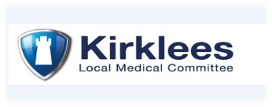
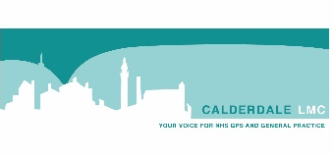

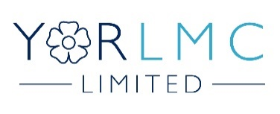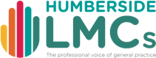
Wakefield Local Medical Committee

