

**Bulletin No 4 from Dr G H Barnes, Medical Referee, Parkwood Crematorium, Elland** February 2021

Thanks to the many who have given attention to the details required in the completion of Cremation Form 4. Standards have improved in recent months, but there are still a number with issues arising. I’m writing to re-state outstanding issues and flag up the need to support colleagues who are still struggling to get it right.

**Issues arising before the onset of COVID 19**

**All questions must be answered in full without exception.** This includes cases where you have not been directly involved in the care of the deceased. There appears to be a problem when completing forms on screen where they can scroll up, concealing the point that a question has not been answered. The remedy is to always re-check the form before submission.

**Question 9 seeks a clinical summary** which should be done in conventional format, in plain language, without jargon or abbreviations. It needs a clear overall picture rather than fine detail of investigation. It was introduced in the 2008 revision, following the publication of the Shipman reports, allowing relatives to link what they understood of the health of the deceased with the cause of death. The form is open to inspection by the applicant for cremation and should be written in language clear to them. It should lead logically to the stated causes of death.

**Question 8 relates to your inspection of the body after death.** The expected answers are:

1. Identification of the body

2. Nature of inspection – external examination or a full pathology post mortem exam. A full statement of the examination protocol is acceptable, but not essential.

3. Most doctors include a statement about hazardous implants, but this is also covered later



**Post COVID19 issues are**

We are using the original forms in a new temporary context, and need to accommodate the changes while still answering the questions asked as they stand, without ambiguity.

**Questions 6-8 need to be answered in the context of your personal involvement.** If you were not involved you must say so, or put ‘not applicable’ and move on.

In order to complete the form you must have **seen the patient within 28 days of death** (including by video, excluding by telephone) **OR** to have seen the body in person after death

**OR**

you must know of **another licensed medical practitioner who has done so and provide their name, GMC number, date and time that they saw the patient and what they observed.** There is no place on the form dedicated to this information.

Most colleagues include a **separate paragraph under Q9** (clinical summary). Avoid getting it mixed up with questions on your involvement (Q6-8). You may need to seek this information from another organisation such as Out of Hours service or Hospital.

**OR**

You have had a discussion with the Coroner or Coroners Officer and you have been informed that form 100A (aka ‘form A’) has been issued to the Registrar of Births, Marriages and Deaths, AND you record this on form 4.

If truly exceptional circumstances apply, an explanatory note may be sufficient to justify an irregularity, otherwise discussion with the coroners officer and a record that form 100A has been issued will allow progress.

***The topic ‘seen by another doctor and not by me’ is currently presenting most problems.***



**Signing the form.**

Most are completed well now, but problems are still appearing. An acceptable signature is one of the following:

1. A standard ‘wet’ handwritten signature

2. An inserted scanned copy of a handwritten signature.

3. An electronic signature set up using the latest electronic template for Form 4 provided by the Ministry of Justice. It looks like this:

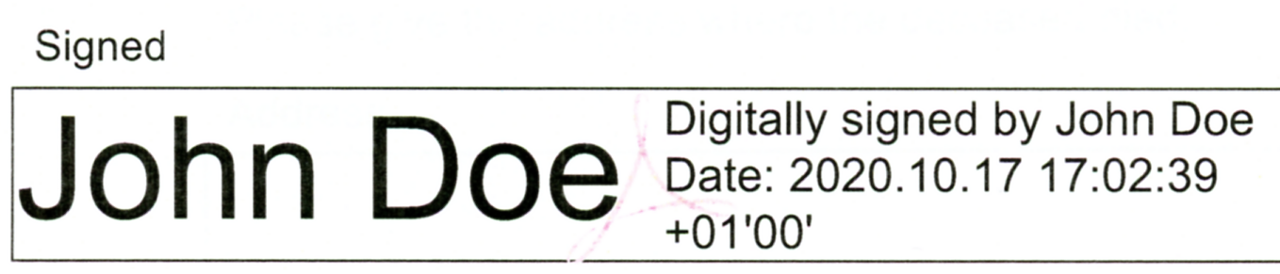

4. The form may be attached to an email direct from your personal Business (NHS) email address. Sending this via a third party is not acceptable.

These are the options recommended by the Ministry of Justice, and while others might be available they will not be accepted unless they have been cleared in advance of submission. Your name typed at the end of the form is not acceptable, even if the font has been changed.

This bulletin explains but does not alter the Revised Guidance to Medical Practitioners for completion of form 4, issued in March 2020, which is based on statute law

https://www.gov.uk/government/publications/medical-practitioners-guidance-on-completing-cremation-forms

If you need advice beyond that already published, please look to a credible source. The crematorium is open between 0830 and 1630 during the week. I will respond to enquiries and can be reached directly around 1400 on weekdays , or by email.

Dr Howard Barnes GMC#1326835

Medical Referee, Parkwood Crematorium

Park Road ELLAND HX5 9HZ

01422 372293

Parkwood.Crematorium@calderdale.gov.uk