**From:** Sophie Boyles [<mailto:Sophie.Boyles@calderdale.gov.uk>]   
**Sent:** 01 September 2020 16:35  
**Subject:** Training Opportunities - CSCP/CSAB

Dear Colleague

This a reminder that the new Calderdale Safeguarding Training platform called Enable has gone live. You will need to register, if you have not already done so, to access the library of resources including e-learning and any virtual or future Face to Face sessions (please note, there will be no face to face training available in the foreseeable future - until at least January 2021).

Please use the enable system to look for dates of any courses being provided virtually in this present time as this is ever changing and the online brochure may not contain the most up to date options available.

Before requesting any training please discuss your learning needs with your manager and select and complete one e-learning course before requesting the next (each time you start a course, this will take up an allocated license so it is essential you complete any courses you start, or ensure you have selected a course that is appropriate to your learning needs/role).

**To Register**

Click [here](https://calderdalescp.vc-enable.co.uk/register) to go to the portal; complete the form, selecting your organisation and the sub-group specific to your job role from the dropdown list (if you cannot find a relevant department, please email [Lisa.Golding-Smith@Calderdale.gov.uk](mailto:Lisa.Golding-Smith@Calderdale.gov.uk) or [Julie.Hartley@Calderdale.gov.uk](mailto:Julie.Hartley@Calderdale.gov.uk) for advice).   Please use your work email address when registering and only use a personal email address if you are unable to provide one for work.

**To Select e-learning**

When you enter your learner workspace you will see the following icons:

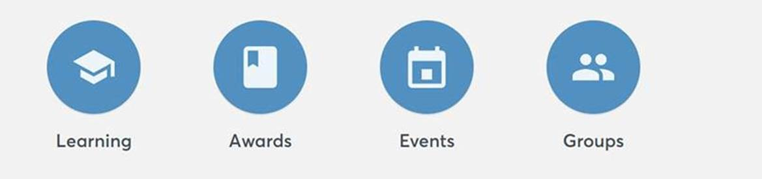

***Learning*** – takes you to view all the e-learning modules that are available to you (please note, if click START you will be allocated a licence for that course which you will be expected to complete within 4 weeks).  Please use the attached guide to inform your choice and only select one course at once.

***Awards*** – will show your certificates.

***Events*** – *Available events* - these are the courses that are currently available as on-line alternatives to face to face sessions.  Please keep checking to see when others have been added.  Any courses prefaced with the word SCHOOLS are for school staff only.

*Active events* – are those which you have booked and have been allocated a place to attend.  Please note: Requests for face to face training will be manually approved by a member of the CSAB/CSCP team before the event appears on your account.

***Groups*** – shows the group you registered with when you created an account.

In addition to this new offer, we have a limited number of licences for **Reducing Parental Conflict**.  If you would like to access this e-learning, please email [Lisa.Golding-Smith@Calderdale.gov.uk](mailto:Lisa.Golding-Smith@Calderdale.gov.uk) or [Julie.Hartley@Calderdale.gov.uk](mailto:Julie.Hartley@Calderdale.gov.uk)

**Virtual Training Courses Available in September**

### *15/09/2020*

### •       Alcohol Brief Intervention Training 09:30–12:00

* Domestic Abuse Briefing: Impact on Children & Young People 13:30 to 15:30

***18/09/2020***

* Reducing Parental Conflict
  + Module 2             9:30 to 13:00
  + Module 3             13:30 to 17:00

***24/09/2020***

* Child Mental Health: Introduction  09:30 - 11:30
* Basic Drugs Awareness, Brief Interventions, Identifying and Supporting Young People who use Substances  10:00 – 12:30

Kind Regards

Sophie Boyles

Quality Assurance Officer

Calderdale Safeguarding Children Partnership and Calderdale Safeguarding Adults Board

Inspection Readiness - Inspection of Local Authority Children’s Services (ILACS), Joint Targeted Area Inspection (JTAI) and Inspection of Youth Offending Work

** **T:    01422 393184

** **M:  07976169514

****      E:  [Sophie.Boyles@Calderdale.gov.uk](mailto:Sophie.Boyles@Calderdale.gov.uk)

     W:  [www.calderdale-safeguarding.co.uk](http://www.calderdale-safeguarding.co.uk)

**Please forward any Inspection Queries or Documents to** [**inspection.readiness@calderdale.gov.uk**](mailto:inspection.readiness@calderdale.gov.uk)