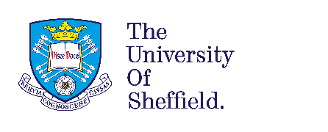

Close Relative Marriage & Genetic Risk:

Providing Effective & Culturally Competent Services

  - Free Online Learning Event
  - 4th September 2020, 9:45 – 15:30
- Close relative (consanguineous) marriage has recognised benefits for couples and families. However, this marriage pattern is linked to an increased risk of genetic disorders.
Poor access to genetic information and services currently leaves many families unsupported.

- This learning event is suitable for anyone working in healthcare, public health, social care or community development, as well as members of the public, who wish to support the development of culturally competent services to address this unmet need.
Midwives, Health Visitors, GPs and Health Promotion practitioners are encouraged to attend.

Six sessions across the day (flexible attendance possible) involving:
- Presentations from academics and professionals.
- Q&A discussions and case studies.
- Take-away exercises and resources.
Facilitators: Naz Khan (Principal Genetic Counsellor, Manchester Centre for Genomic Medicine), Sarah Salway (Professor of Public Health, University of Sheffield), Parveen Ali (Senior Lecturer in Nursing, University of Sheffield) and other experts.

An opportunity to:
- Enhance understanding of: cultural context; patterns and levels of risk in context; service gaps and unmet needs
- Increase awareness of guiding principles and promising approaches to improving access to culturally competent services and to increasing genetic literacy
- Increase confidence and competence to contribute within your own role
  - Please publicise this event through your networks
  - To sign-up please follow this link: https://forms.gle/kxrRHFLdXDCVRCSj8
  - For further information, or if problems registering, email cgarner1@sheffield.ac.uk

