**Safeguarding Training platform (Enable)**

I am pleased to advise you that the new, improved, Safeguarding Training platform (Enable) is now live!!This platform will give you access to the same e-learning as before (some courses have been updated or renamed), a couple of new additions (relating to Safeguarding Adults) and is the way to book on to face to face training.

Please note, until face to face training resumes in January 2021 at the earliest, we are hoping to offer some of these sessions online.   Currently, only the courses that have confirmed will go ahead online from September 2020 (one from July 2020) are visible – please keep checking to see when other courses are added.  The full programme will be available for you in the next few weeks to book a place for face to face training once it is reinstated.

Before requesting any training please discuss your learning needs with your Manager and select and complete one e-learning course before requesting the next.  Details of all the e-learning courses available are attached.

**To Register**

Click [here](https://calderdalescp.vc-enable.co.uk/register) to go to the portal;

Complete the form, selecting your organisation and the sub-group specific to your job role from the dropdown list (if you cannot find a relevant department, please [email me](mailto:Allison.Waddell@calderdale.gov.uk) for advice).   Please use your work email address when registering and only use a personal email address if you are unable to provide one for work.

**To Select e-learning**

When you enter your learner workspace you will see the following icons

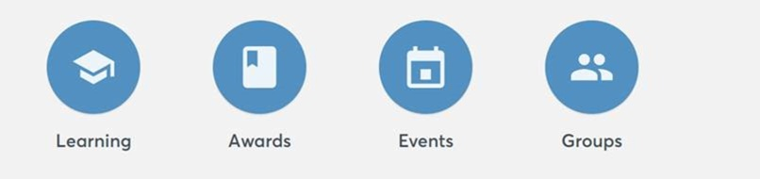

**Learning** – takes you to view all the e-learning modules that are available to you (please note, if click START you will be allocated a licence for that course which you will be expected to complete within 4 weeks).  Please use the attached guide to inform your choice and only select one course at once.

**Awards** – will show your certificates.

**Events** -

*Available events* - these are the courses that are currently available as on-line alternatives to face to face sessions.  Please keep checking to see when others have been added.  Any courses prefaced with the word SCHOOLS are for school staff only.

*Active events* – are those which you have booked and have been allocated a place to attend.  Please note: Requests for face to face training will be manually approved by a member of the CSAB/CSCP team before the event appears on your account.

**Groups** – shows the group you registered with when you created an account.

In addition to this new offer, we have a limited number of licences for **Reducing Parental Conflict**.  If you would like to access this elearning, please email me direct.

Kind Regards

Allison

Allison Waddell

CSAB/CSCP Learning and Improvement Officer

Safeguarding & Quality Assurance Service

2nd Floor, Princess Buildings, Princess Street

Halifax, HX1 1TS

Tel: 01422 394108 Mob: 07714922642