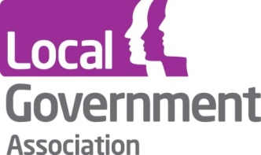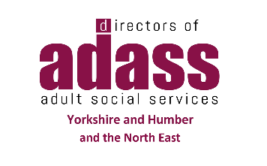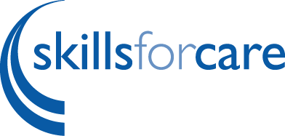

North-East and Yorkshire COVID-19
Re-thinking the Reset – Support for Care Homes
Online Seminar - 23rd June 2.00-3.30pm

Book a place and circulate to colleagues!
The care sector is crucial in supporting vulnerable people live as independently as possible and is a critical component in the systemwide response to managing the COVID-19 pandemic. Across the North-East and Yorkshire partners including; Care Providers, Local Government, NHS organisations, the Care Quality Commission, Public Health and Skills for Care have worked closely together to continue to provide the care and support needed by vulnerable citizens and carers.
To support colleagues across the region to coordinate approaches, share intelligence and good practice, sustain the on-going response, and prepare for the future at regional, system and local levels in an effective and joined-up way, we are planning a Re-thinking the Reset series of on-line seminars for the North-East and Yorkshire focused on the Care Sector. The seminars are being put together by partners across the NHS, Local Government/ADASS, CQC, and Skills for Care.
In recent weeks there has been increased national attention paid to care homes, and so the first seminar in the series will focus on that part of the system. There has been new guidance for the NHS and Local Government, including the publication of a national social care action plan and national models for primary care and community services and it is important that we have a shared understanding across the region of how these (and other developments) are working together, what is working well, and how we can use our collective learning as we begin to plan for the next phase and reset of the system.
The aims for the on-line seminar are to:
- Reflect on the latest national guidance, planning and support arrangements across primary care, community services and social care
- Update on the Enhanced Care Homes Universal Support Offer
- Share learning from the recently completed Care Home Support Plans
- Hear how integrated support from Health & Care teams has impacted on citizens and their carers
- Showcase some of the wider developments and innovation across the region and how they have benefitted people who use our services
The seminar is aimed at people across the health and care sector, in leadership, commissioning and operational roles.

For further information and to book a place go to https://www.events.england.nhs.uk/events/re-thinking-the-reset---support-for-care-homes-online-seminar-96735

