Lower Limb Guideline Launch Celebration Event – Upper Valley
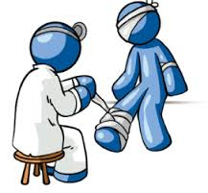
Wednesday March 21st, 12:00-13:30pm, Grange Dene Medical Centre, Mytholmroyd.

- Includes a presentation and workshop covering recent changes to the lower limb management guidelines and sharing of ideas for implementing into clinical practice.
- Provides an opportunity for communicating and networking with the multidisciplinary team and aims to streamline appropriate and timely patient care by the right professional, in the right place, at the right time.
- Kindly Supported by BBraun Medical – Karen Jeffrey (clinical educator) will be attending to provide education around the prevention and management of wound biofilm, and reducing unnecessary prescribing of antibiotics when managing chronic wounds such as leg ulcers.

- Lunch will be provided.

Please contact Vicky.storey@cht.nhs.uk to confirm attendance.

