Lower Limb Guideline Launch Celebration Event – Central Halifax
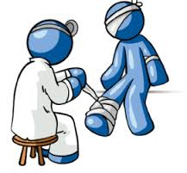
Tuesday March 20th, 11:30am – 1:00pm, Beechwood Health Centre, Ovenden.

- Includes a presentation and workshop covering recent changes to the lower limb management guidelines and sharing of ideas for implementing into clinical practice.

- Lymphoedema specialist nurse presentation outlining appropriate management of wet legs / chronic leaking oedema, the importance of identifying the difference between varicose eczema and cellulitis, and management of recurrent episodes of lower limb cellulitis.
- Provides an opportunity for communicating and networking with the multidisciplinary team and aims to streamline appropriate and timely patient care by the right professional, in the right place, at the right time.
- Lunch and refreshments will be provided. With kind support from 3m Healthcare.

- Afternoon practical skill workshops will be available for community nursing staff who wish to update their bandaging and Doppler assessment skills, after the lunchtime launch event.

Please contact Vicky.storey@cht.nhs.uk to confirm attendance.

