Lower Limb Guideline Launch Celebration Event – Lower Valley
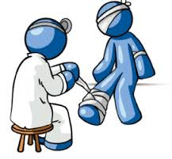
Monday March 19th, 11am – 1:30pm, Holiday Inn – Brighouse

- With kind support from Thornton and Ross who will be providing education about assessing and monitoring the diabetic foot, management of dry skin conditions, and total emollient therapy.

- Includes a presentation and workshop covering recent changes to the lower limb management guidelines and sharing of ideas for implementing into clinical practice.

- Provides an opportunity for communicating and networking with the multidisciplinary team and aims to streamline appropriate and timely patient care by the right professional, in the right place, at the right time.

- Lunch and refreshments will be provided.

Please contact Vicky.storey@cht.nhs.uk to confirm attendance.

